Determining The Value Of End Of Vector by using matrix

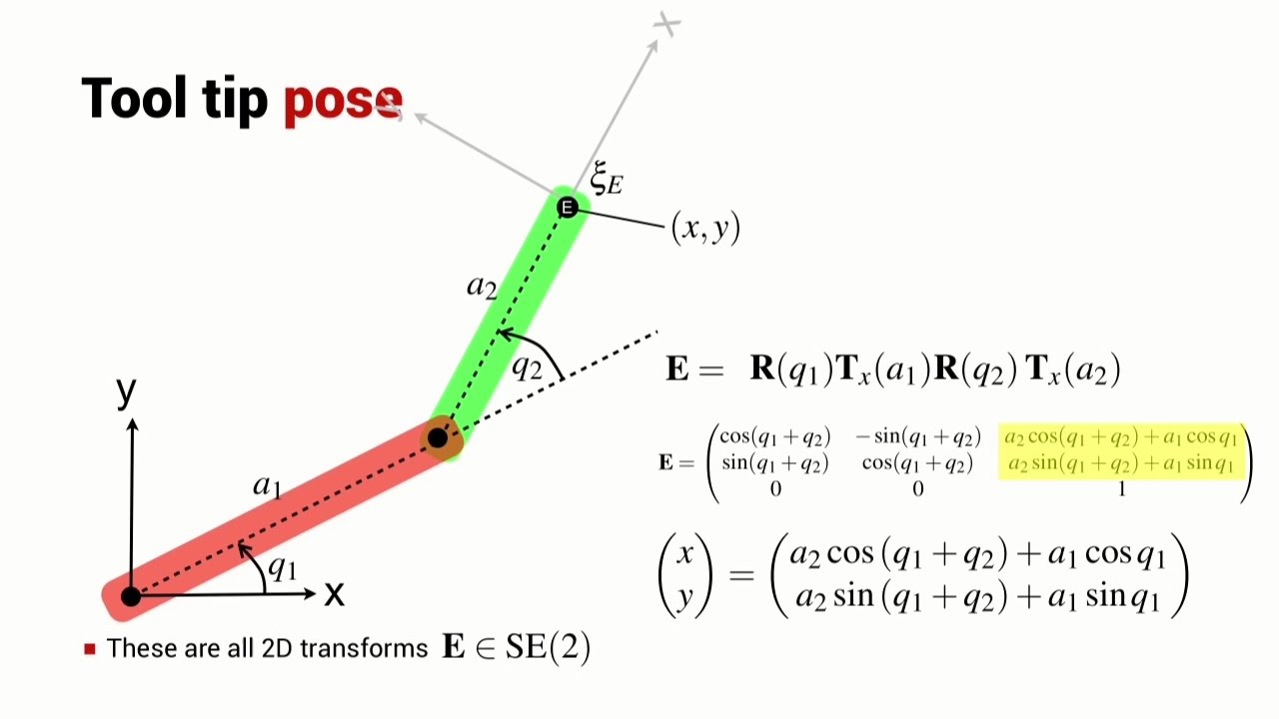

Figure 1 end of vector

1. The axis is rotated by q1 and transferred in the x-axix by a1.
2. The new axix is rotated by q2 and transferred in the x-axix by a2.
3. The rotation and transformation can be rebresented in matrix form.
4. The end of vector will equal the multiblication of steps 1 and 2 using the matrix proberties. (it represented in E in figure 1)

* Forward Method: the x and y obtained from the last coulme of the matrix E directly.
* Invese Method: the E matrix will be known. Then, we will use the inverse matrix properties to obtains the values of q1 and q2.

The above method can be used to determine the end of vector for any degree of fredom in 2D or 3D.